scanf() 🡪 to read a string  
getchar() 🡪 to read a line of text

gets() 🡪 to read line of text  
puts() 🡪 to print line of text

**Frequency of characters**  
Number of occurrences of a particular character in a word

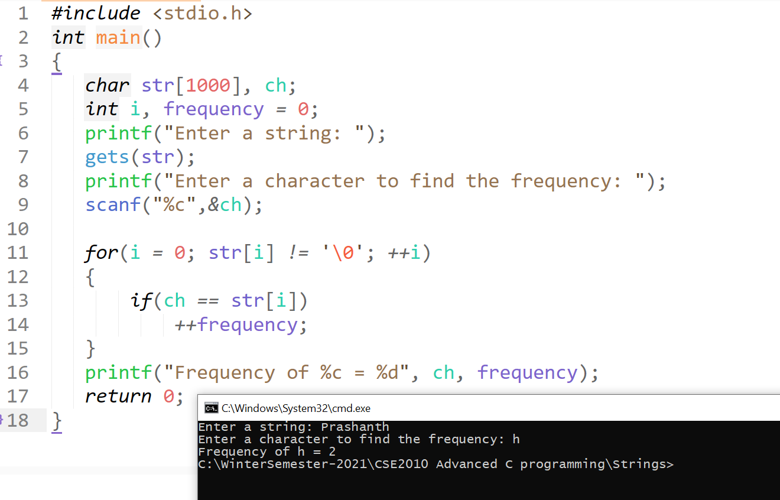

**Copying of strings manually without using strcpy**

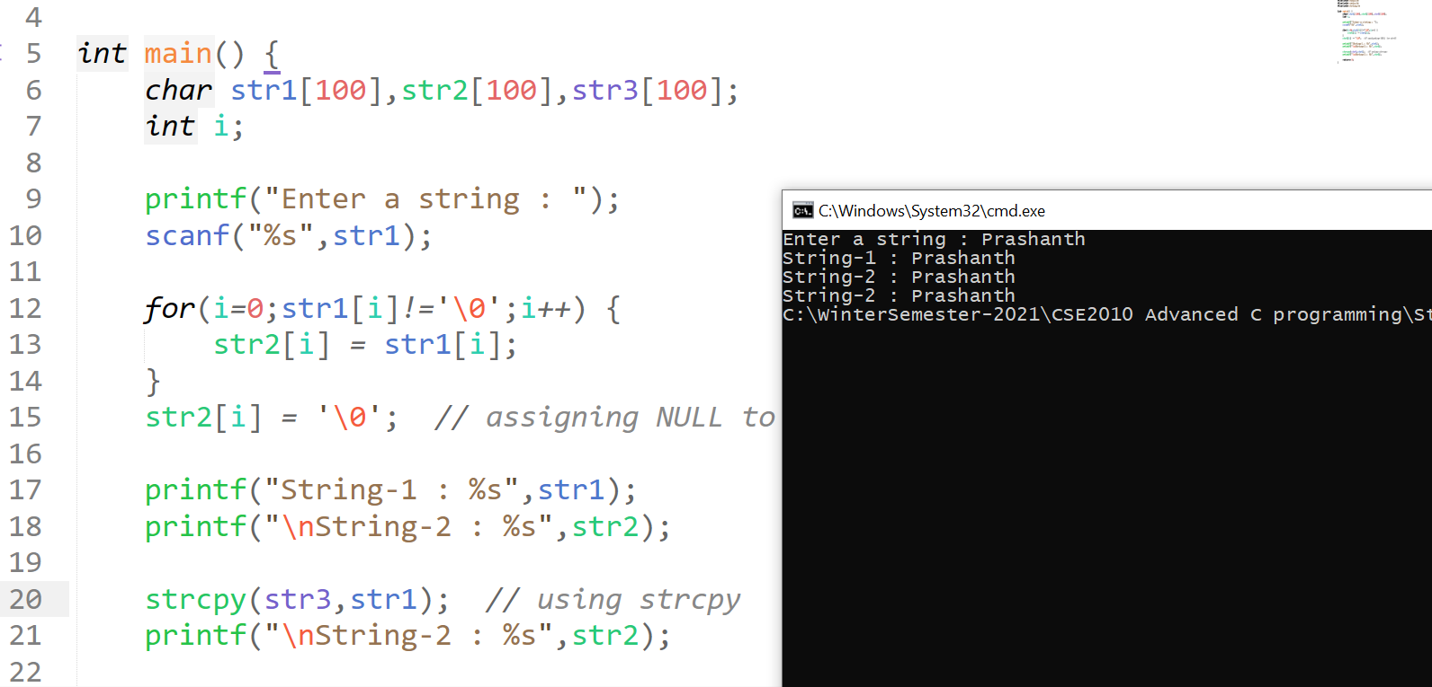

**Calculating the string length without using strlen**

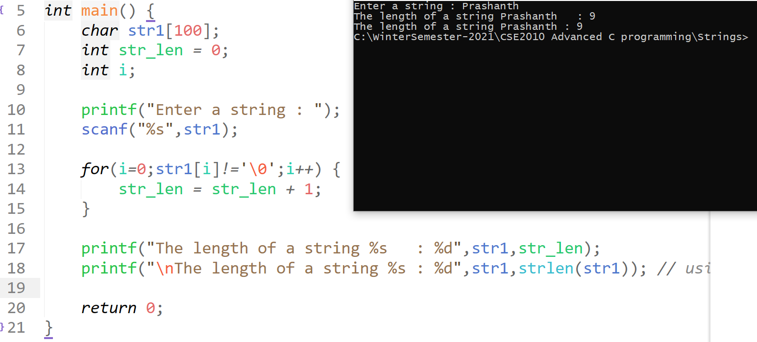

**Concatenate two strings without strcat()**

